#208
The Cold War (1945-1991)
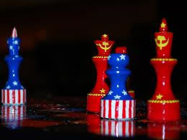
As WWII came to a close, the world hoped for peace... but that peace never came. After WWII, the once-mighty nations of Japan, Germany, and Great Britain lay in ruins. Only two nations came out of the war strong enough to lead the war: these "superpowers" were the United States and the Soviet Union. Unfortunately, the United States and the Soviet Union had deeply different ideas, values, and ambitions. Their differences would lead to the Cold War, which would last more than 40 years and would include smaller wars such as the Korean War and Vietnam War.

Communism vs. Capitalism
The Cold War began in 1945 when the dictator of the Soviet Union, Joseph Stalin, took over several countries in Eastern Europe. Stalin had made the Soviet Union into a communist country, and was now trying to spread communism to other countries around the world. The U.S. was capitalist and did not want communism spread anywhere.

1) The Soviet Union's Communism: The Soviet Union's communism was born out of the ideas of Karl Marx, who wrote the Communist Manifesto. Marx described an ideal society where everyone worked to benefit everyone else. However, when Joseph Stalin created communism in the Soviet Union, it was nothing like the way Marx described. The Soviet people were forced to work on government-run farms and factories. To protect his power, Stalin turned the Soviet Union into a vast (huge) police state. No one was safe from the prying eyes and ears of Stalin's secret police. Millions of people that were suspected of criticizing Stalin were ruthlessly murdered or imprisoned. The Soviet Union became a brutal dictatorship.

2) The United States’ Capitalism: Americans saw communism as a cruel system that took away people's property. They were disgusted by what Stalin was doing and even more appalled that Stalin's Soviet Union was doing everything it could to spread communism to other countries. President Truman responded to the threat of communism with a new foreign policy known as containment. The goal of this policy was to keep communism from spreading to any further by containing, or limiting it from spreading to any new countries.

The Nuclear Arms Race
When the United States dropped atomic bombs on Japan in 1945, a frightening new age began – the Atomic Age. Four years later (helped by spies) the Soviet Union successfully tested their own atomic bomb. Soon both sides were developing nuclear weapons – even more powerful versions of the atomic bomb. Suddenly, the world was faced with the reality of “Mutually Assured Destruction” or “MAD” – the threat of unthinkable destruction if war broke out between the superpowers. This is what made the Cold War so terrifying.

The Arms Race Begins: Shortly after the end of the war, President Truman announced his plans to develop a hydrogen bomb. This was a nuclear weapon that would be hundreds of times more powerful than the bomb that had destroyed Hiroshima in 1945. The Soviet Union worked to match Truman's goal and develop the hydrogen bomb before him. This resulted in a nuclear arms race – a competition to develop ever more powerful and destructive weapons. By 1953, both superpowers had tested their first hydrogen bombs. By 1960, both superpowers could launch nuclear missiles at each other from the land, air, and sea. When John F. Kennedy became president in 1961, each superpower had enough nuclear weapons to destroy the other many times over (“MAD”).
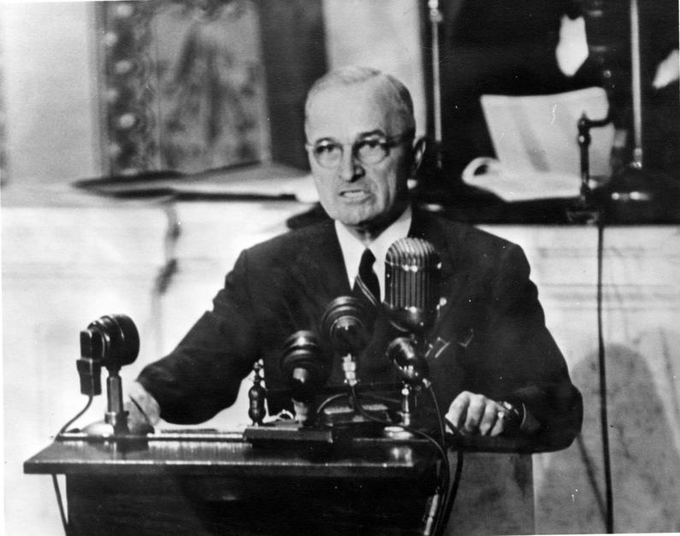
The Truman Doctrine
In 1947, President Harry Truman announced the United States policy toward dealing with the Soviet Union. His policy became known as the “Truman Doctrine.” The following is what he said in his 1947 Address to Congress: “At the present moment in world history nearly every nation must choose between alternative ways of life.… One way of life is based upon the will of the majority, and is distinguished by free institutions, representative government, free elections, guarantees of individual liberty, freedom of speech and religion, and freedom from political oppression. The second way of life is based upon the will of a minority forcibly imposed upon the majority. It relies upon terror and oppression, a controlled press and radio, fixed elections, and the suppression of personal freedoms. I believe that it must be the policy of the United States to support free peoples who are resisting attempted subjugation by armed minorities or by outside pressures. I believe that we must assist free peoples to work out their own destinies in their own way. I believe that our help should be primarily through economic and financial aid which is essential to economic stability and orderly political processes.” Write down in 2 or 3 sentences what Truman is saying he will do: _____________________________________________________________________________________
______________________________________________________________________________________________________________________________________________________________________________________________________________________________________________

The Marshall Plan & The Berlin Airlift
After World War II, the leaders of the Soviet Union in Moscow had hoped the poverty of war-torn Western Europe would give them the opportunity to spread Communism into Western Europe. In 1948, President Truman, with the approval of Congress, established the Marshall Plan. The Marshall Plan granted $12,500,000,000 to repair the economic damage of World War II.
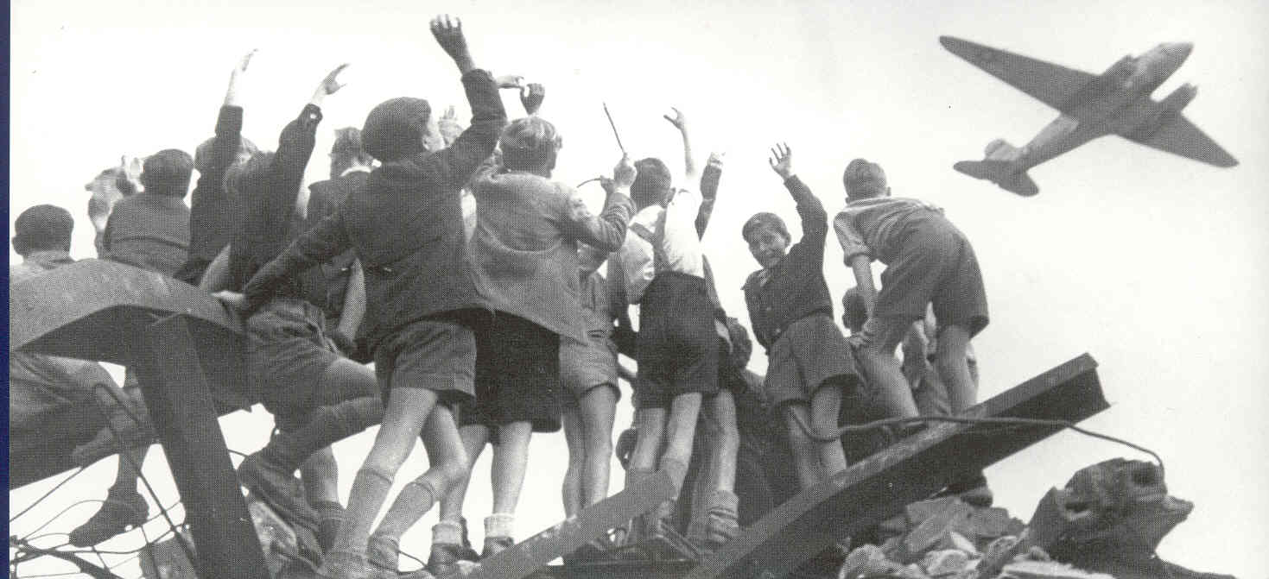
The Marshall Plan shocked the Soviet leaders in Moscow. They would no longer be able to use the poverty in Western Europe to spread Communism. Moscow's reaction to the Marshall Plan was swift. By July 1, 1948, the Soviet Union had blocked all land and water routes into West Berlin. This is called a blockade. The people of West Berlin could not survive long without food, coal, or other supplies. They would be forced to become part of Communist East Germany. President Truman was faced with this situation. What would you have done to save the people of West Berlin from Communism?
President Truman and military leaders thought about and flying supplies into West Berlin. They were not sure if they should continue with this very risky course of action. Remember, if the United States showed off its military strength and tried to force the Soviet Union to open up the land and water routes into West Berlin, it could lead to another war. Truman decided to risk it.
The Western Allies organized what came to be known as the Berlin Airlift to carry supplies to the people in West Berlin. From June, 1948 to May, 1949, airplanes from the U.S., U.K., and other allied air forces flew over 200,000 flights, providing up to 4,700 tons of daily necessities such as food and fuel to the Berliners. By the spring of 1949, with the Berlin Airlift clearly succeeding, the humiliated Soviets lifted the blockade. The first “battle” of the Cold War, and the largest humanitarian effort the world had ever seen, had been won by the United States.

