#198
ARMENIAN GENOCIDE

On August 22, 1939, in preparation for his invasion of Poland, Hitler stated to his commanding generals:
“Our strength is our quickness and our brutality… What the weak Western European civilization alleges about me, does not matter. I have given the order—and will have everyone shot who utters but one word of criticism—that the aim of this war… consists in… the enemies' physical elimination. Thus, for the time being only in the east, I put ready my men… with the order to kill without pity or mercy all men, women, and children of the Polish race or language. Only thus will we gain the living space that we need. Who still talks nowadays of the extermination of the Armenians?”

The Armenian genocide was one of the most massive exterminations ever carried out against a defenseless people. In 1915, as World War I raged, the Turkish government (rulers of the Ottoman Empire – present-day Turkey) decided upon the systematic extermination of most of the male Armenian population, and the forced deportation of the remainder, mostly women, children, and the elderly. The deportation became a death march, with extreme violence and deprivation leading to the death of most Armenians – as was intended. By the time the exhausted and traumatized survivors reached refuge in neighboring countries, up to three-quarters of the entire Ottoman Armenian population had been exterminated.

The events of World War I, which saw Turkey allied with Germany and Austria-Hungary against Britain, France, and Russia, gave these architects of genocide the opportunity they sought to implement their plan of killing the Armenians. One of the movement's leaders, Dr. Nazim, told a government committee in February 1915, that "if this purge is not general and final, it will inevitably lead to problems. Therefore it is absolutely necessary to eliminate the Armenian people in its entirety, so that there is no further Armenian on this earth and the very concept of Armenia is extinguished. We are now at war. We shall never have a more suitable opportunity than this."
The slaughter began on April 24, 1915, when some 600 upper class Armenians, all male, were rounded up in Istanbul and murdered. Today, April 24 is commemorated by Armenians worldwide as "Genocide Memorial Day." Much worse was to come. In the following months, the Turks set out to kill all Armenian men. The government “drafted” them into the army for WWI, where they found themselves transformed into laborers and worked to death. The government then started to “relocate” the rest of the men to live in other parts of the Ottoman Empire (what other groups have we studied that have been “relocated”?). After they rid themselves of most Armenian men, they set out to get rid of the women and children. They were forced from their homes at bayonet-point and put on forced marches. Those who lagged behind were bayoneted on the road or pushed off of bridges. As a proportion of population, it is believed that between 1/2 and 3/4 of all Ottoman Armenians died in the genocide. This is a death rate comparable to the Jewish Holocaust, in which some 2/3 of European Jews were killed.

Turkey's defeat in World War I, and the consequent collapse of the Ottoman Empire, offered surviving Armenians an opportunity for national self-realization. In 1918, an independent Republic of Armenia was declared. Today, the government of Turkey still denies that any genocide took place.

Scarred by History: The Rape of Nanjing
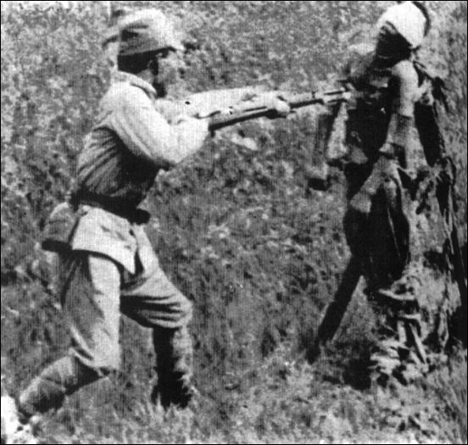
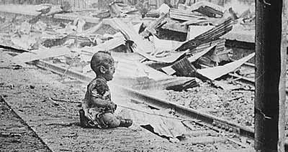
Between December 1937 and March 1938 one of the worst massacres in modern times took place. Japanese troops captured the Chinese city of Nanjing and embarked on a campaign of murder, rape and looting. Approximately 300,000 people were killed, many of them women and children. The number of women raped was estimated to be 20,000, and there were widespread accounts of civilians being hacked to death. Yet many Japanese officials and historians deny there was a massacre on such a scale. They admit that deaths and rapes did occur, but say they were on a much smaller scale than reported. And in any case, they argue, these things happen in times of war.

'The memories cannot be erased'
A Christian missionary, John Magee, described Japanese soldiers as killing not only "every prisoner they could find but also a vast number of ordinary citizens of all ages. Many of them were shot down like the hunting of rabbits in the streets." After what he described as a week of murder and rape, the Rev. Magee joined other Westerners in trying to set up an international safety zone. Another who tried to help was an American woman, Minnie Vautrin, who kept a diary that has been likened to that of Anne Frank. Her entry for 16 December reads: "There probably is no crime that has not been committed in this city today. Thirty girls were taken from the language school [where she worked] last night, and today I have heard scores of heartbreaking stories of girls who were taken from their homes last night - one of the girls was but 12 years old." Later, she wrote: "How many thousands were mowed down by guns or bayoneted we shall probably never know. For in many cases oil was thrown over their bodies and then they were burned. Charred bodies tell the tales of some of these tragedies. The events of the following ten days are growing dim. But there are certain of them that lifetime will not erase from my memory and the memories of those who have been in Nanjing through this period." Minnie Vautrin suffered a nervous breakdown in 1940 and returned to the US. She committed suicide in 1941. Also horrified at what he saw was John Rabe, a German who was head of the local Nazi party. He wrote about rape and other brutalities that occurred even in the middle of the supposedly protected area. He became leader of the international safety zone and recorded some of what he saw on film, but this film was banned by the Nazis when he returned to Germany. Why do you think this film was banned in Germany? (http://www.snagfilms.com/films/title/nanking/)
Confession and denial
After the Second World War was over, one of the Japanese soldiers who was in Nanjing spoke about what he had seen. Azuma Shiro recalled one episode: "There were about 37 old men, old women and children. We captured them and gathered them in a square. There was a woman holding a child on her right arm... and another one on her left. We stabbed and killed them, all three - like potatoes in a skewer. I thought then, it's been only one month since I left home... and 30 days later I was killing people without remorse [regret]."
GENOCIDE IN RWANDA

In 1994, there was a genocide in Rwanda – a small country in Eastern Africa. In over 100 days it is estimated that 800,000 people died. The fighting was between two ethnic groups called the Hutus and the Tutsis. The Hutus wanted power and overthrew the Tutsi monarchy who controlled Rwanda from 1959-1962. There was a civil war between the two groups in the 1980s. To separate the two groups people in Rwanda were given id cards. Skin color was a general physical trait that was typically used in "ethnic" identification. Tutsis, the minority group, were the lighter-colored Rwandans, while the darker-skinned Rwandans were typically Hutu, the majority group in Rwanda.
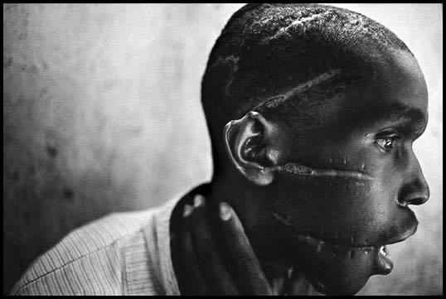
The news media played a crucial role in the genocide; local print and radio media fueled the killings while the international media either ignored or seriously falsified events. The Rwandan military and Hutu militia groups set out to murder all the Tutsis they could reach, regardless of age or sex. Most of the victims were killed in their own villages or in towns, often by their neighbors and fellow villagers. People were typically murdered by machetes, although some army units used rifles. The Hutu gangs searched out victims hiding in churches and school buildings, and massacred them. Local officials and government-sponsored radio incited ordinary citizens to kill their neighbors, and those who refused to kill were often murdered on the spot. Either you took part in the massacres or you were massacred yourself. Rape was also a part of the genocide Estimates were that between 250,000 and 500,000 Rwandese women and girls had been raped.



