#105
Religion in Rome

Last class, we learned about how the Roman Empire eventually collapsed in AD 476. We learned that there were many political, social, economic, and military causes that led to the fall of the Roman Empire. However, the last straw was when Emperor Diocletian split the Roman Empire into two parts: the Eastern Roman Empire and the Western Roman Empire. The Western Roman Empire was invaded by Germanic Tribes and fell into ruin. After the Western Roman Empire collapsed, all of western Europe became disorganized and disunified. For hundreds of years afterwards, Western Europe was a mess. This period in Western Europe is called the Dark Ages because of the disorder and lack of learning. On the other hand, the Eastern Roman Empire lived on and became the “Byzantine Empire”. The Byzantine Empire will be a major focus of our next unit.
Last class, we also learned about Roman contributions. The greatest Roman contribution was in the area of law. Rome created a set of laws called the Twelve Tables, which marked the first time in history that laws were created to apply to all of the people equally. Many of our laws today come from the Roman Twelve Tables including equality for all people under the law and the idea of being innocent until proven guilty.
Today we will learn about religion in Rome. This is a little more complicated than religion in Greece because the religion of Rome changed dramatically in 392 AD. Romans had always practiced polytheism and had gods that were very similar to the Greek gods. However, that all changed in 392 AD when Emperor Constantine made Christianity the official religion of Rome.

I. Polytheism in Rome:
During the Roman Republic and most of the Roman Empire, the Roman people believed in gods and goddesses, which were largely adopted from the ancient Greeks. Just like the Greek gods, these gods were believed to control everything from falling in love to killing food for dinner. Romans believed religion was very important. They believed that gods were responsible for putting them on Earth and controlling their lives. Religion was a huge part of Romans’ every day lives and each family prayed to the gods in the morning.
Like the Greeks, Romans built grand temples to honor their gods and goddesses. At the temples, Romans prayed and gave gifts such as animals to the gods. Romans thought that gifts would please the gods. If the gods were happy, Romans thought they would receive good luck in return. If something went wrong, they believed that the gods were angry with them.
Most of the Roman gods were the same as the Greek gods, although they had different names. For example, while Zeus (god of the sky and weather) was the head god in Greece, Jupiter was the head god in Roman religion. Jupiter, the ruler of the Gods, was the god of sky, lightning and thunder. His wife, Juno (named Hera according to the Greeks) was also his sister. She was the guardian of the Empire's finances ($$$) and the head goddess of all Rome. How else are these gods similar to the Greek gods?
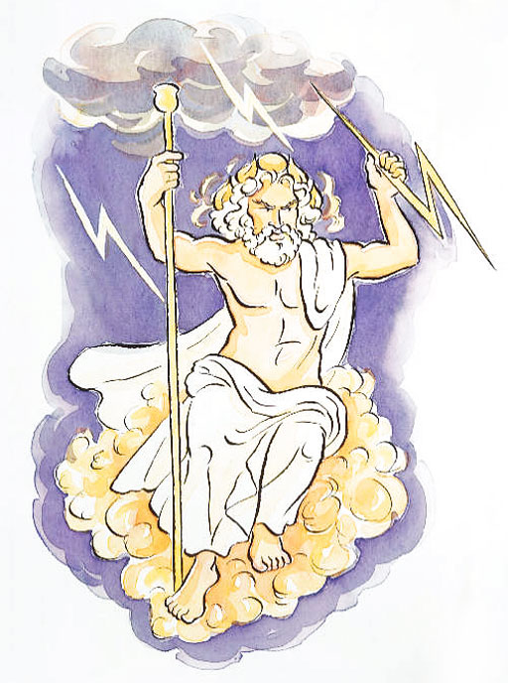
Jupiter Juno

This polytheistic religion was a huge part of life in Ancient Rome. However, the development of Christianity threatened to change all of that.

II. The Influence of Jesus:
Rome conquered Jerusalem in the year 6 AD – around the time that Jesus was born. Remember that Jerusalem was the home of the Jews who believed that it was their promised land, and that Jesus was a Jew. The Romans thought that Jesus, who was preaching that there was only ONE G-d, was a big threat to their religion and their way of life. So in 33 AD, Jesus was arrested and crucified (hung on a cross) by the Romans. The Roman government was unsure about what they should do with this new group of Christians that followed the teachings of Jesus, and what they should do with the Jews who also only believed in one G-d. These religions seemed dangerous to Rome because their polytheistic religion had united and brought peace to the Roman people for so long. So, they kicked the Jews out of Jerusalem in 70 AD. However, Christianity continued to spread, which scared the Romans. Romans persecuted (mistreated) the Christians, but that did not stop the spread of Christianity. Why do you think that Christianity continued to spread even though Christians were being mistreated? Why did it continue to spread when it was so different from the religion that had been practiced in Rome for so long?
Christianity spread for many reasons. First of all, the poor, the mistreated, the unhappy, and the slaves found comfort in Jesus’ message of love and a better life after death. Secondly, Christian missionaries (people who spread religion) often added Greek and Roman ideas and philosophies into their teachings, which made sense to the more educated Romans as well as others. Thirdly, missionaries, such as Paul (from the Bible), worked hard to spread Christianity throughout Rome.

III. Rome becomes Christian:
When Constantine became the Emperor of the Eastern Roman Empire in 306 AD, he shocked everyone by declaring himself a Christian. Constantine saw that Christianity could actually UNITE the empire instead of dividing it. Emperor Constantine ended the persecution of Christians with the Edict of Milan, which said that everyone in Rome had the right to practice whatever religion they wanted. Licinius, the Emperor the Western Roman Empire, also agreed to the Edict of Milan when he married Constantine's sister.
Constantine also moved the capital of the Eastern Roman Empire to the city of Byzantium and renamed it after himself. He called it Constantinople (today it is called Istanbul and is located in the country of Turkey). Constantine called the city of Constantinople, "New Rome." Actually, he was right. After the Western Roman Empire fell apart, Constantinople continued to thrive and grow. It became the center of the Byzantine Empire (which would rule this area for the next thousand years).
After Constantine ended the persecution of Christianity, the religion continued to grow. Christianity was finally legal in the Empire, and for the first time, Christians were allowed to openly worship. Churches were quickly built not just in Rome but also throughout the empire. In AD 391, the worship of other gods was made illegal and Christianity became the official religion of the Roman Empire. However, in less than 100 years, half of the Roman Empire would fall and the other half would become the Byzantine Empire. Even though the Roman Empire fell, Christianity moved on.

