#107
Nationalism

After the French Revolution, there was a reaction against revolutionary ideas. In 1815, at the Congress of Vienna, the leaders of the nations of Europe restored the old monarchies. In the following decades, conflicts between revolutionary ideals and the desire to maintain the old order would cause uprisings and repression. Although some reforms slowly took hold in Western Europe, Russian Tsars/Czars continued to rule Russia with absolute power. What countries do you think are included when we talk about “Western Europe”?
The Congress of Vienna

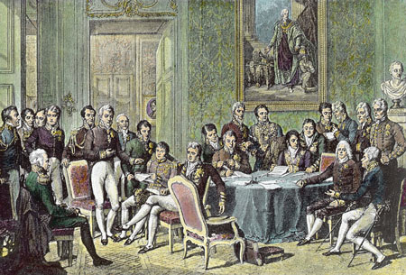
After Napoleon’s defeat, European diplomats met at the Congress of Vienna (Vienna is the capital of the western European country of Austria, not to be confused with Australia) in 1815 to restore order and stability to Europe. There were many different countries represented at the meeting, but it was dominated by Prince Clemens von Metternich of Austria. The one thing they could all agree on was that they wanted to create a balance of power in Europe, or a distribution of military and economic power that prevents any one nation from becoming too strong. They did this by restoring old regimes to power. Who was in charge of these “regimes”?

New Revolutions in Europe
The Vienna settlement helped to maintain peace among nations in Europe for almost 100 years (until WWI). However, revolutions did occur within nations. What is it called when you have a revolution within a nation? Revolutionaries in these countries were not happy with the results of the Congress of Vienna. They opposed the Congress’ policy of trying to restore Europe to the way it had been before the French Revolution. Revolutions occurred in many European countries in 1830 & 1848, to limited success.

Unification of Germany and Italy
As you have learned, nationalism is a feeling of strong devotion to one’s country. This feeling often develops among people who share something in common, like language or heritage. Revolution and war in the 1790s created a strong sense of national unity in France and led to the French Revolution and Napoleon’s reign. Napoleon also inspired nationalism in the nations he conquered. This nationalism led conquered peoples to rise up against Napoleon. In the years following the French Revolution, nationalism led to upheaval in Europe and elsewhere. In 1848, revolutions occurred in parts of the Austrian empire, Italy, and Germany. Throughout the continent of Europe, people sought to get rid of foreign influence and develop unified, independent nation-states. Two main countries were affected by this unification movement – Italy and Germany.
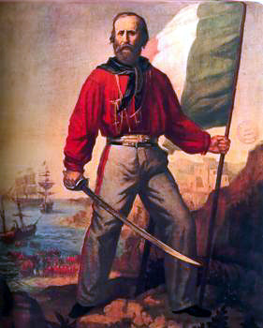
Italy – after the fall of the Roman Empire, Italy had been divided into many small states. After Napoleon invaded Italy, he united some of the Italian states into the Kingdom of Italy. The Congress of Vienna, however, redivided Italy and put much of it under Austrian or Spanish control. Two men were mainly responsible for the unification of Italy in the 1860s – Camillo Cavour, a diplomat from southern Italy, and Giuseppe Garibaldi, a soldier who won many battles in his efforts to reunite Italy.

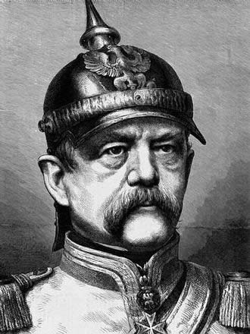
Germany – like Italy, Germany consisted of a number of small states. Chief rivals for the leadership of Germany were the two largest German states – Prussia and Austria. Austria, however, contained many non-German lands and peoples. The leaders of Austria therefore did not want to see Germany united.
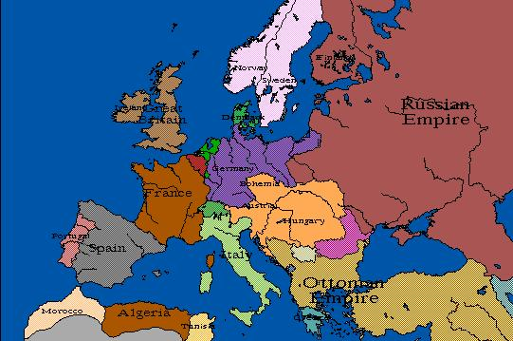
Although the revolutions of 1848 failed to unite Germany, a man by the name of Otto von Bismarck succeeded in doing this during the 1860s. Bismarck was the Prime Minister of Prussia. He followed a policy of “blood and iron.” What do you think this means? Von Bismarck had no faith in representative government. He believed that the only way to unite the German states was through war. Prussian military leaders made use of new technologies, like the railroad and the rifle, to build the most powerful army in all of Europe. In 1871, the German states united under the Prussian king, William I. As their ruler, William called himself the “Kaiser”, a title that was derived from the name Caesar and meant “emperor.”

