#127

Introducing the Deadliest War Ever… World War I

History has forgotten World War I in comparison to its more popular younger brother, World War II, but the First World War was very significant for many reasons. First, World War I was the deadliest conflict there had ever been. WWI was also a turning point. New weapons technology was used that could kill more people quicker. What do we know about how wars were fought in the 1800s and early 1900s?
The last reason World War I is so significant is the way it ended. The agreement that was signed to end the war severely punished Germany, which eventually made the Germans poor enough and desperate enough to rely on the man who would cause World War II, Adolf Hitler.
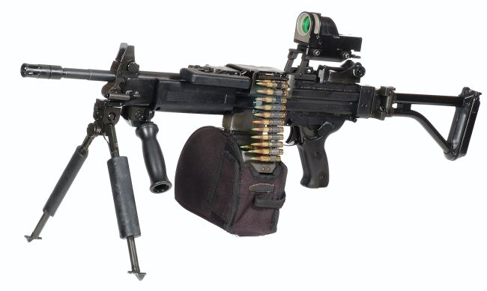
World War I got underway in 1914, but the main causes of the conflict had been building for a long time. The Industrial Revolution had created a competition among European countries. Part of the competition was based on nationalism – each country wanted to be supreme. Another part of the competition was based on territory and resources. In Africa, Asia and elsewhere, European countries used imperialism to determine who could colonize more land. To protect and defend themselves during this competition, many of the European countries started building up their militaries. The Industrial Revolution created newer, more powerful weapons like tanks and machine guns and European countries raced to arm themselves with the most deadly technologies. Finally, these European countries wanted to make sure they weren’t alone in this competition. Therefore, many of these countries formed alliances as a form of protection.
This competition was getting increasingly fierce during the end of the 19th century and during the beginning of the 20th century (during the end of the Industrial Revolution). The competition was mostly taking place outside of Europe, though, as countries scrambled to gobble up Africa’s natural resources. It wasn’t until a Serbian man assassinated Franz Ferdinand, a powerful political leader from the Austria-Hungary Empire, that the battles started in Europe. Austria-Hungary teamed up with Germany, Serbia created an alliance with Russia, and the war was on!
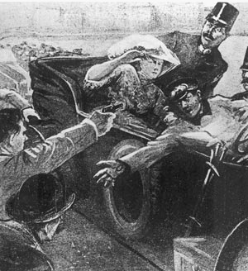
Until World War I ended in 1918, Europeans and their colonies battled ferociously. India, a British colony, sent 1,300,000 million soldiers to support the war. Brazil sent warships and soldiers. Even Japan got involved – World War I was truly a global battle on an epic scale. Overall, more 70 million people fought in World War I! How do you think that compares to the population of New York?

70 million people is the populations for New York, New Jersey, Rhode Island, Connecticut, Pennsylvania, Massachusetts, Delaware, New Hampshire, Vermont, Maine, Maryland, and Virginia, COMBINED. HOLY COW!!! The fighting involved never-before used technologies that were more lethal than anything previously used. Planes were used for the first time as well as poisonous gases. Overall, more than 15 million people were killed during World War I – which at that time was the most people ever killed in a war.
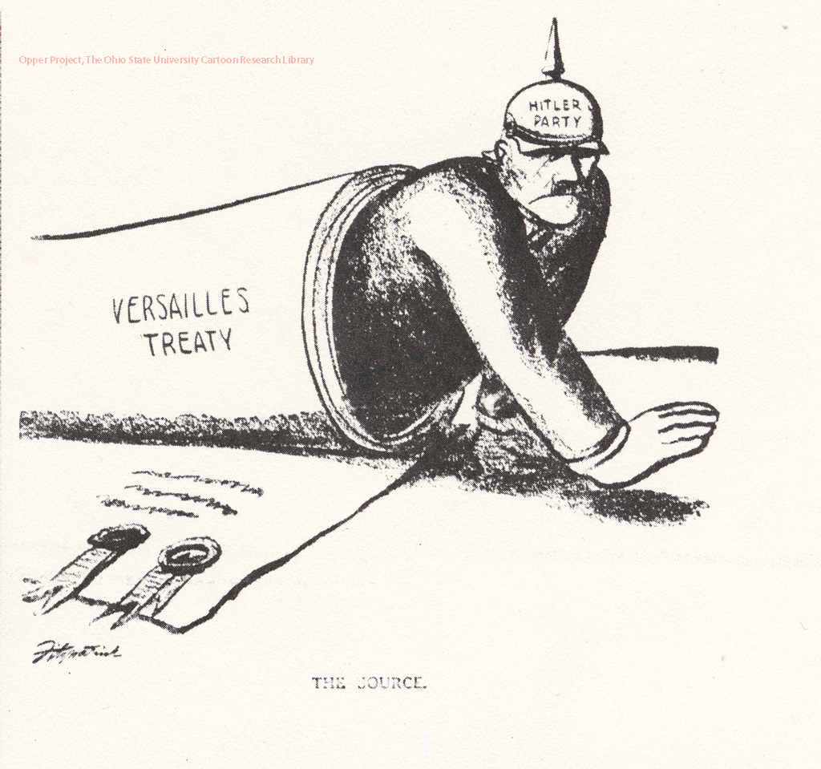
People who were alive during WWI thought this war would be the “war to end all wars,” but maybe the most tragic part about WWI is that it ended up causing another war. The Treaty of Versailles was an agreement to end the fighting during World War I. The problem was that the treaty put all of the blame for the war on the Germans, who then had to pay lots of money and give up a lot of land. The harsh punishment wrecked the German economy and eventually made the Germans so desperate for increased nationalism they turned to a radical politician – named Adolf Hitler.

WORD BOX:
Stolen Alliances Europe Austro-Hungary Revenge Entente Britain Militarism

Using the word box on the right, write out the following text, adding in the words.

Europe was divided into two _ . These were called the Triple and the Triple ____ . Members of each alliance promised to fight for the other members if they were attacked. It would only take a small incident to spark a war that involved the whole of ______ .

Germany had been trying to build up her navy and her empire. ____ was worried about this. Both countries raced each other to build the best navy. There was tension between the two countries. This cause was ____________.

The area south and south-east of ___________-___________ was known as the Balkans. This whole area was very unstable. The European Alliances had different ideas of how to deal with problems.

France was keen for _____________ on Germany. The French had been badly defeated by Germany in 1871 and forced to cede the lands of Alsace and Lorraine. The French wanted their land back! They said it had been ___________ from them by Germany.
W

