#144
RUSSIA: WHERE CAN YOU VISIT?
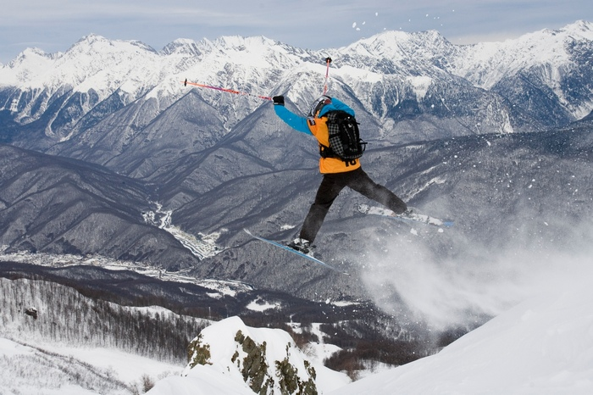
Sochi
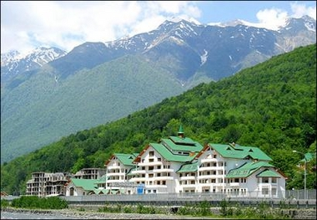
Sochi is a city in between the Caucasus Mountains and the Black Sea. The location has made it a popular vacation spot because of all the activities in the area (like skiing, left). The Winter Olympics will be held in Sochi in 2014.

Moscow
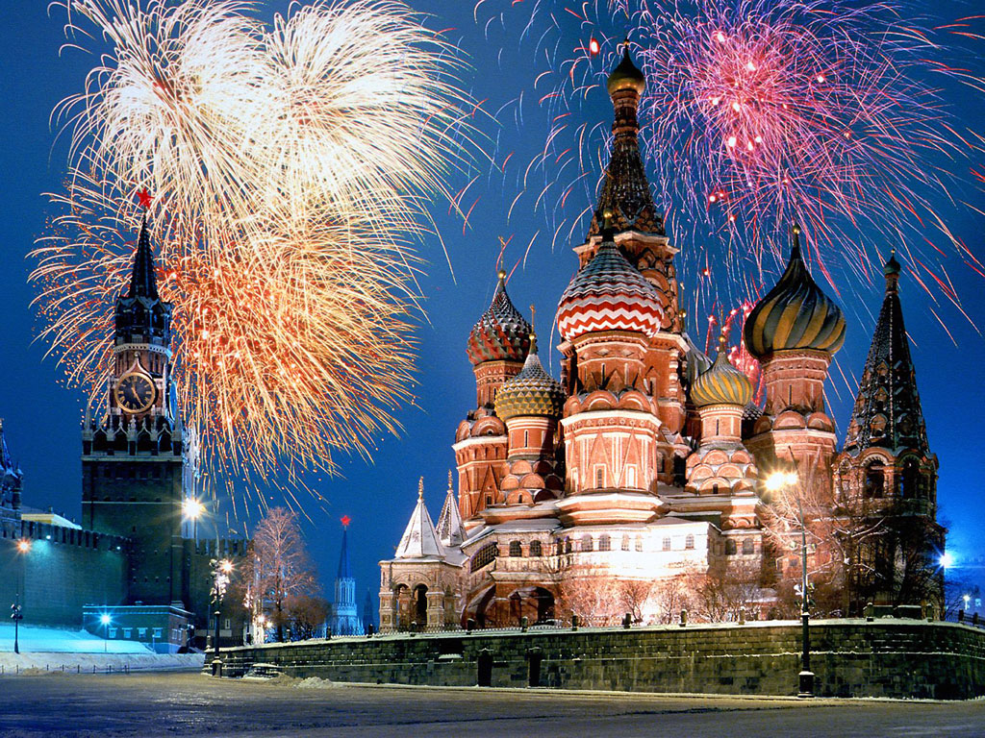
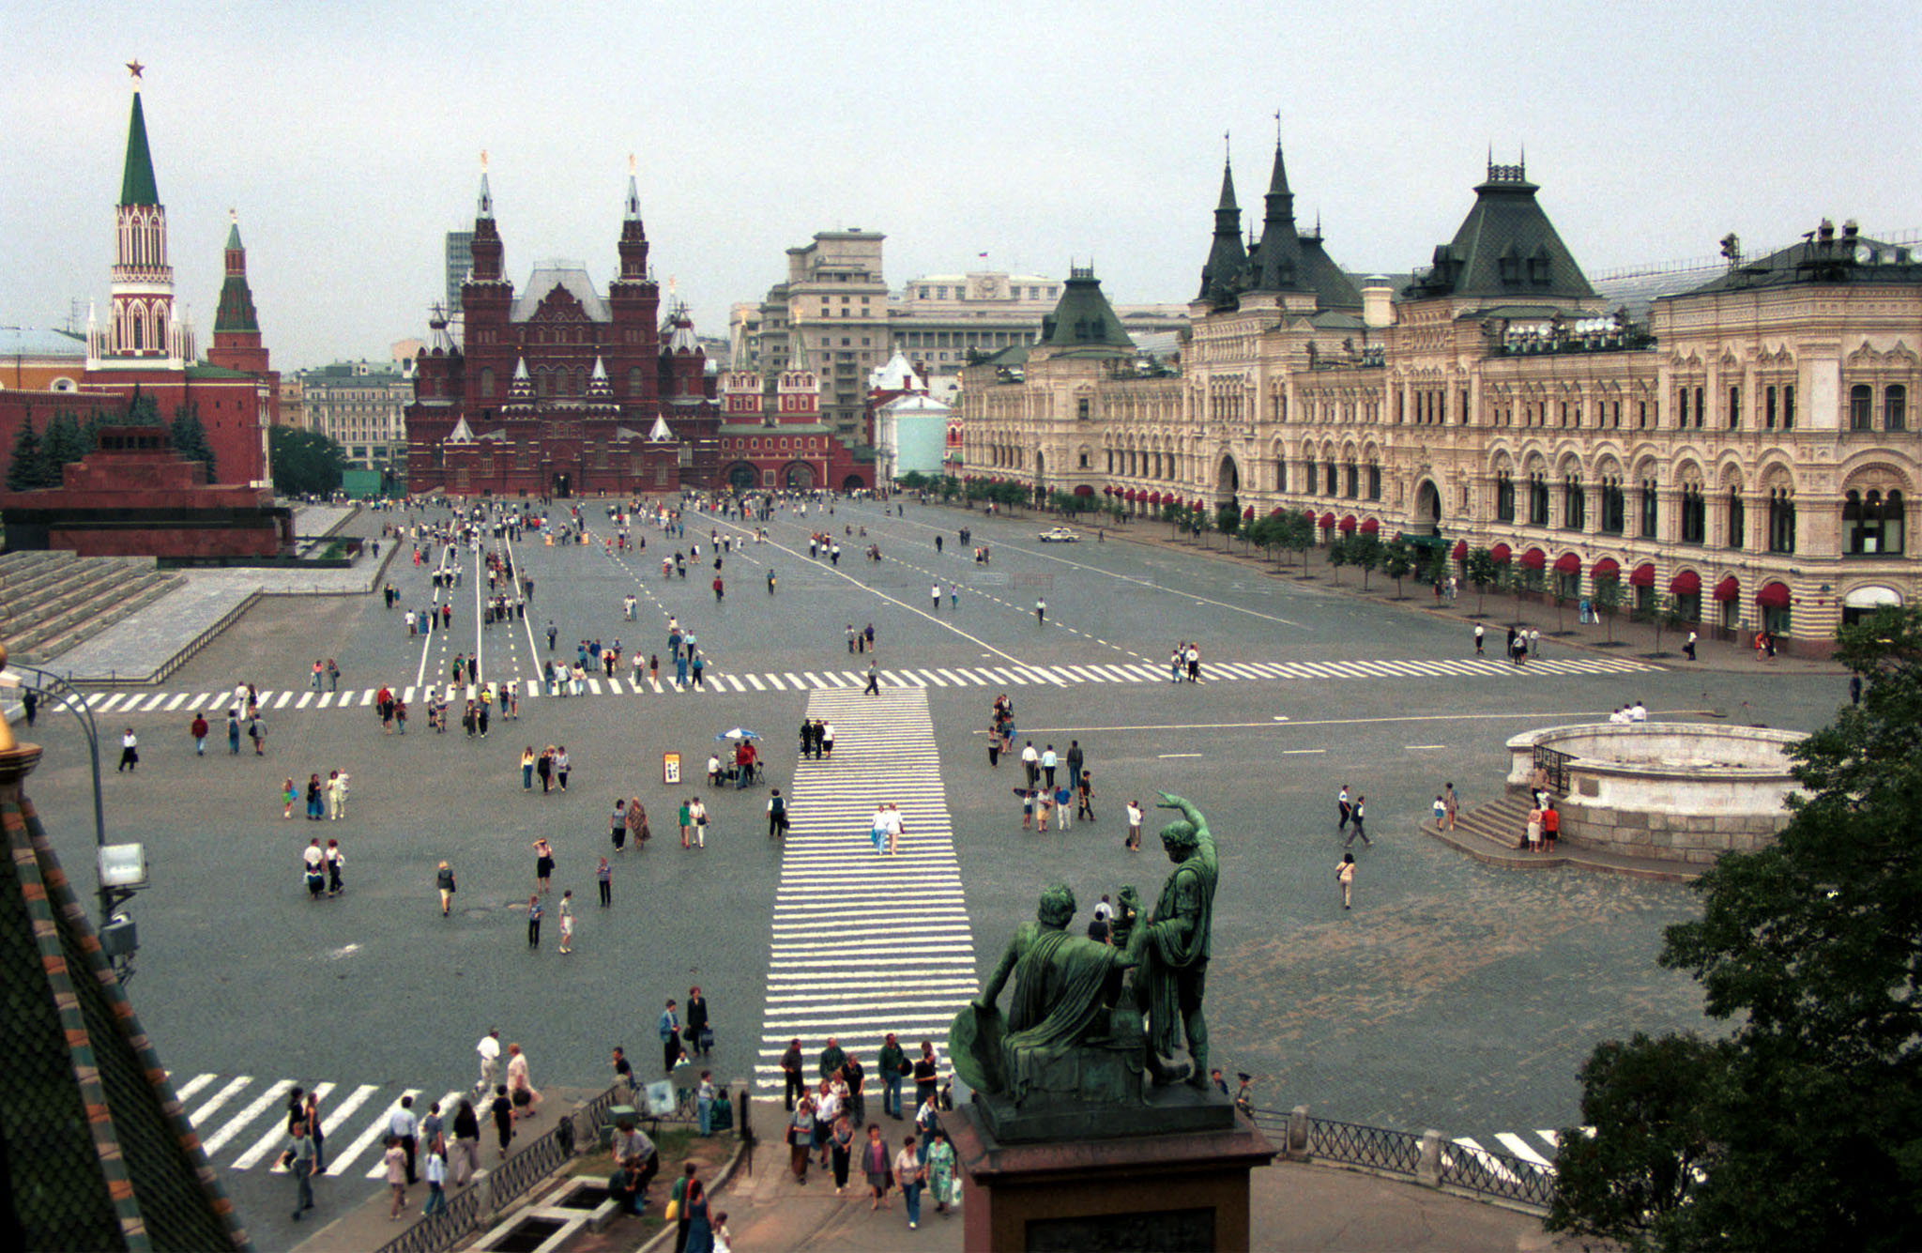
The capital city of Russia is home to more than 10 million people as well as the Russian government and the major tourist sights. The Kremlin (in the picture to the left) is home to the government, while the Red Square (below) is a huge public area. As Napoleon’s troops found out, Moscow can get very cold in the winter – occasionally as cold as 44 degrees Fahrenheit!

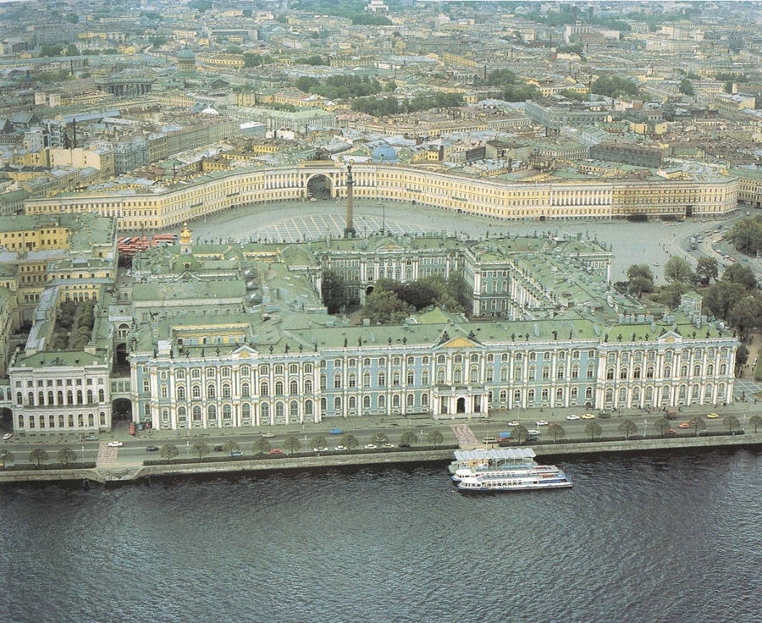
St. Petersburg
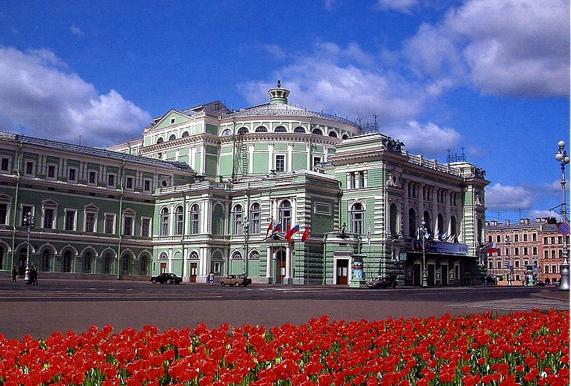
If you seen an old map of the Soviet Union and can’t find St. Petersburg, don’t be confused. Until 1991, the city now known as St. Petersburg was called Leningrad (to honor you-know-who). Today, the city is the place to be for Russia’s best music scene – from rock to opera, especially at the Mariinsky Theatre (left). Tourists also flock to the Hermitage (right), located next door to the former home of Czar Nicholas II. Today the Hermitage is a huge art museum with the largest collection of paintings in the world. James Bond’s Golden Eye is among the movies that have been filmed there.
RUSSIA: IS IT LIKE THE UNITED STATES?
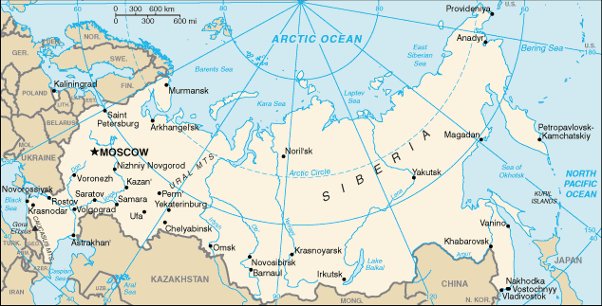
TOTAL AREA:
- Russia: 17,075,200 square kilometers
- U.S.: 9,826,630 square kilometers

POPULATION:
- Russia: 140,702,096
- U.S.: 303,824,640

LIFE EXPECTANCY
- Russia: Men – 59.19 years; Women – 73.1 years
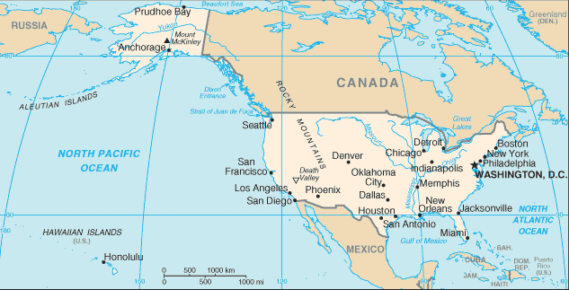
- U.S.: Men – 75.29 years; Women – 81.13 years

INDEPENDENCE
- Russia: August 24, 1991 (from Soviet Union)
- U.S.: July 4, 1776 (from Great Britain)

INTERNET USERS
- Russia: 30 million
- U.S.: 223 million

COLDEST PLACE
- Russia: Siberia (read below)
- U.S.: Alaska

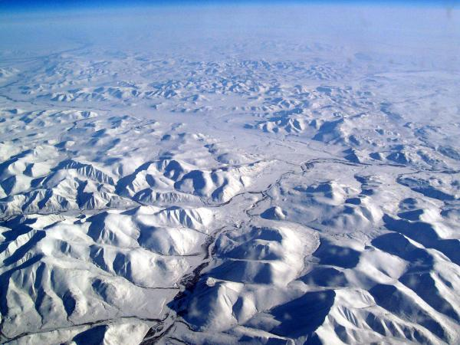
Siberia

Siberia is the name of the region that takes up the eastern part of Russia. Siberia covers three-quarters of Russia’s land but only one-quarter of Russia’s population lives there. Why? It’s so cold! For years, Siberia was where prisoners were exiled as punishment. Some survived; some didn’t. This time of year it is about five degrees in Siberia. The picture to the right was taken from an airplane as it flew over Siberia – does it look like a great place to live?
RUSSIA: WHAT DO THEY EAT?

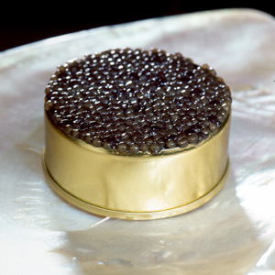
One of the things Russians like to eat is caviar. Caviar is fish eggs and, believe it or not, it is a delicacy in Russia (a delicacy is something pleasing to eat that is considered rare or luxurious). Caviar is normally eaten on crackers or blini, a small, thin pancake.

Why is caviar so expensive?

Basically there is a high demand for caviar and a low supply. Part of the reason there is a low supply is because the fish need to have grown for eight to 10 years. Then farmers need to open the fish and remove, salt and pack the eggs.

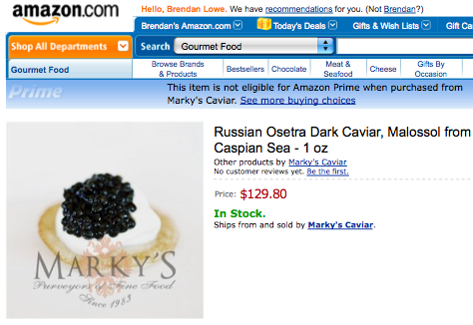
There are also fewer fish because several of the waterways around Russia where lots of caviar comes from have been polluted. Some countries are now taking other fish eggs and dying them black or red (the normal colors of expensive caviar) so they have something to sell.

