#169
Aim: _________________________________________________________________________

______________________________________________________________________________
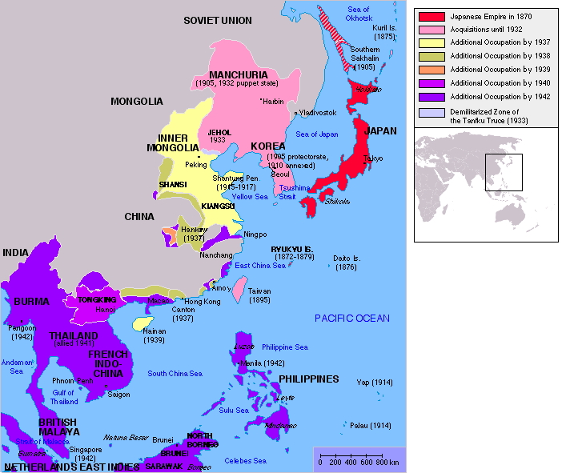
According to this map, what did Japan begin to do after World War II?
___________________________________________________________
___________________________________________________________
Background on Adolf Hitler

1889 – Born in Austria-Hungary in 1889

1890s – Showed interest in war;
personality changed w/brother’s death

1900s – Expelled from school;
struggled to make a living as an artist

1914-1918 – Fought in WWI (1914-1918)

1919 – Joined National Socialist (Nazi) Party;
became famous giving speeches against Treaty of Versailles

1923 – Attempted to overthrow government; arrested for treason; Gained popularity in courtroom speech

1924 – Jailed for one year; let out early

1925 – Wrote Mein Kempf (My Struggle) while in jail

1920s – Spoke out against Wiemar Republic, democratic gov

1930 – Great Depression strikes Germany; gov criticized

1932 – Barely lost presidential election; campaigned with slogan ‘Hitler over Germany’

1933 – Appointed as Chancellor (co-leader) b/c of public
pressure

