#181
Winston Churchill on the Policy of Intervention
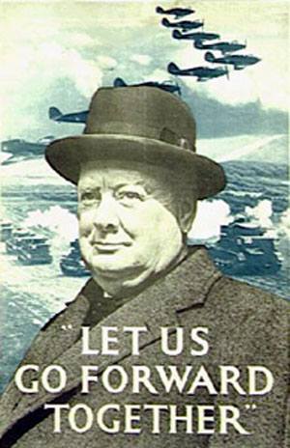

Winston Churchill took over as Prime Minister of Great Britain after Chamberlain. Churchill was a former British soldier who had fought in World War I. Those experiences led him to be much more interested in going after Hitler than Chamberlain had been.

As the war dragged on, times got tough for Britain. For a while, Churchill’s strategy was to keep his country independent and functioning long enough for the United States to join. Eventually, after London had been bombed and Britain was in desperate shape, Churchill’s strategy paid off. Roosevelt teamed up with Churchill and the Allied Forces defeated the Axis Powers. Throughout the war, Churchill’s speeches, which steadfastly maintained Britain would emerge victorious, gain the British confidence in their leader and their country.
----------------------------------------------------------------------------------

May 13, 1940: Churchill’s first speech as prime minister, after taking over for Chamberlain:

“I would say to the House, as I said to those who have joined this Government. I have nothing to offer but blood, toil, tears, and sweat. We have before us many long months of toil and struggle.

“You ask what is our policy. I will say, it is to wage war with all our might, with all the strength that G-d can give us, to wage war against a monstrous tyranny never surpassed in the dark, lamentable catalogue of human crime.

“You ask what is our aim? I can answer in one word: Victory. Victory at all costs. Victory in spite of all terror. Victory however long and hard the road may be. For without victory there is no survival.”

Churchill’s Biblical Quote on Intervention:
“Arm yourselves, and be ye men of valour, and be in readiness for the conflict; for it is better for us to perish in battle than to look upon the outrage of our nation and our altar.”

Churchill’s Quote on Chamberlain:

-- “He was given a choice between war and dishonor. He chose dishonor and he will have war anyway.”
-- “An appeaser is one who feeds the crocodile hoping it will eat him last.”
-- I never worry about action, but only about inaction.”

Comprehension Questions – TO BE ANSWERED ON LOOSELEAF

- What does Churchill mean when he says, “I have nothing to offer but blood, toil, tears, and sweat?
- What is Churchill’s policy/plan? How is this policy similar to or different from Chamberlain’s?
- What is Churchill’s aim/goal? Why is this aim so important?
- Churchill quotes from the Bible. Put the quote in your own words.
- Based on the quotes, what does Churchill think about Chamberlain? How can you tell?

