#183
WORLD WAR II BEGINS!

Over the past few days, we have discussed how the harsh provisions of the Treaty of Versailles, combined with the weakness of the League of Nations, led to World War II. In the face of this weakness, Germany, Japan, and Italy, formed the Berlin-Tokyo Axis. These nations agreed to fight Soviet communism and not to stop each other from making foreign conquests.
It soon became clear that appeasement had failed. Several events led to a declaration of war. In March 1939, Hitler took over the rest of Czechoslovakia. The western democracies, upset at Hitler for breaking the terms of the Munich Conference, did nothing. They did, however, tell Hitler that if he attacked Poland, they would respond militarily. In August 1939, Hitler made a pact with Joseph Stalin of the Soviet Union. In this Nazi-Soviet Pact, the two enemies agreed not to fight one another. In September 1939, Germany invaded Poland, crossing the line that the Allies had set. Finally, Britain and France responded by declaring war on Germany. World War II had begun.
The war was initially fought between the Axis powers (Germany, Japan, Italy) and the Allied Powers (Britain and France, later joined by the Soviet Union and the U.S.). At first, Germany and its allies were successful. Nazi forces conquered Poland in a swift, massive attack known as blitzkrieg or lightning warfare. In April 1940, Hitler overran Norway, Denmark, the Netherlands (Holland), and Belgium. By June 1940, the Germans had conquered France and entered Paris. The leader of France, Charles de Gaulle, formed a French government in exile, calling on French forces to continue fighting Germany. These “Free French” worked from England to liberate their homeland.

Turning Points of the War
The Axis Powers won quick victories in the first several years of the war. Several events after 1940, however, are seen as turning points for the Allies.

The Entry of the United States
Although the United States was officially neutral at the beginning of the war, they shared a common interest with the Allies in the desire to end Nazi tyranny. They sold arms to the Allies and banned the sale of arms to Germany and Japan. Angered by the ban, Japan launched a surprise attack on American military bases at Pearl Harbor, Hawaii, on December 7, 1941. More than 2,400 people were killed and many ships and planes were destroyed. In response, President Franklin D. Roosevelt asked Congress to declare war on Japan. The entry of the United States into the war gave the Allies added strength.

The “Blitz”
Both the Allied powers and the Axis powers engaged in a total war. Cities became targets of bombing. In 1940, Germany began a blitz, or massive bombing, of London, using warplanes. Winston Churchill, prime minister of Britain, rallied his people.

Primary Source – Churchill’s “We Shall Never Surrender” Speech

“We shall go on to the end, we shall fight in France,
we shall fight on the seas and oceans,
we shall fight with growing confidence and growing strength in the air, we shall defend our Island, whatever the cost may be,
we shall fight on the beaches,
we shall fight on the landing grounds,
we shall fight in the fields and in the streets,
we shall fight in the hills;
we shall never surrender….”
-- Winston Churchill, 4 June 1940

Russian Battles (1942-1943)
The Germans invaded the Soviet Union in 1941. After steadily advancing, they became stalled outside Moscow and Leningrad. Russian troops and a freezing winter caused the German invaders to surrender in 1943. The Red Army [Russians] drove the Germans out of the Soviet Union. Soon Soviet troops were advancing toward Germany.

Invasion of Normandy (1944)
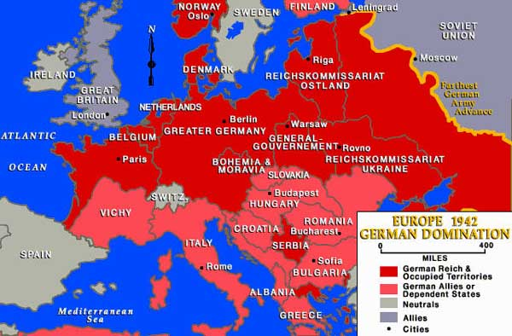
The Allies invaded France on June 6, 1944. Allied troops were ferried across the English Channel, landing on the beaches of Normandy, France. They broke through the German defenses to advance toward Paris and freed France from German control. The Allies then moved from France into Germany.

