#203
UNIT 8: Non-European Empires of the Middle Ages
Today we begin a brand new unit of study in Global History. This is our 8th unit and it is called "Non-European Empires of the Middle Ages.” So far, we have learned that the Middle Ages refers to a time period from about 500 C.E. to 1500 C.E. We know that during this time Europe was in a "dark ages" that was characterized by feudalism, the Church, the Plague, and the Crusades. During this time Japan was characterized by feudalism, Shintoism, Buddhism, cultural diffusion from China through Korea, and the Tokugawa Shogunate. We also know that during this time the Byzantine Empire was thriving in Turkey and other parts of eastern Europe, the Arab Empires were thriving in the Middle East, and the Tang, Song, and Mongol Empires were thriving in China and other parts of Asia.
During this unit we will learn what was happening during this time period in other parts of the world. We will learn about what was going on in North & South America and Africa. We will begin this unit right now, with a look at the Americas.
Geographic Setting – MesoAmerica
Human beings first came to America during the Paleolithic Stone Age. This was tens of thousands of years ago. Cavemen and cavewomen traveled from Asia to the top of North America, over a bridge (made of either land or ice) connecting the continents of Asia and North America. Over the years these early human beings traveled south through the Americas and learned to farm and to domesticate animals. This huge change - from hunting and gathering to farming and raising animals – is called the Neolithic Revolution. These changes led to an increase in the population. In the Americas, complex societies developed. In Mexico, the Olmecs, and later the Mayas and Aztecs ruled great empires. In South America, the Incas ruled and conquered huge amounts of land along the western coast. The people in these empires were skilled farmers, were devoted to their religion, and possessed advanced knowledge in many areas.
In the Americas, just like in Africa and Eurasia, this Agricultural Revolution had a huge effect. Farmers settled into villages that sometimes developed into large religious centers, which could then grow into major cities. The first great American civilizations developed in Mesoamerica (also called Middle America), in the region that includes Mexico, Central America, and parts of South America.

The First American Empire: The Olmecs
The first major American civilization was the Olmec Empire. The Olmec Empire lasted from around 1400 B.C.E to 500 B.C. It emerged in the tropical forests along the gulf coast of Mexico. Instead of cities, the Olmecs built ceremonial centers made up of pyramid-shaped temples and other buildings.
The Olmecs invented a calendar and developed a system of writing made up of carved inscriptions. Due to trade with other American peoples, they had a huge influence on other people living in Central America. Perhaps the most important legacy of the Olmecs was their devotion to religion and their especially honored class of priests. These characteristics were common in later Mesoamerican civilizations. The most important thing about the Olmecs was their influence on later Mesoamerican societies. These later Mesoamerican societies include the Mayas and the Aztecs.

THE MAYAS
The Mayas began to settle the Yucatan Peninsula around 900 B.C.E. The Mayas were at the peak of their civilization from about A.D. 300 to 900. During this period, the Mayas developed a complex agricultural society. They established large city-states in southern Mexico and throughout much of Central America. Do you remember what a city-state is? What other civilization that we have studied developed city-states?

I. FARMING AND TRADE: Farmers made up most of the Mayan population. Men usually cultivated the crops while women were in charge of turning these crops into food. Farmers paid taxes, in the form of food, to support the cities and their temples. Traders, who accumulated much wealth, traded valuable honey and cocoa (chocolate) across Central America on long hard-packed dirt roads.

II. RELIGION: The Mayan religion was characterized by the worship of nature gods (especially the gods of sun, rain, and corn), a priestly class, the importance of astronomy and astrology, rituals of human sacrifice, and the building of elaborate pyramid temples. Some aspects of Mayan religion survive today among the Mayan Indians of Mexico and Central America, who practice a combination of traditional religion and Roman Catholicism. Because of the significance of religion to the Mayas, priests were at the top of their social hierarchy. These religious leaders held such importance because they alone could conduct the elaborate rituals that the Mayas believed would ensure bountiful harvests (food) and victories in battle. The importance of religion to the Mayas may be judged from the size of their temples. Priests climbed these tall structures to perform rituals while the common people watched from far below.

III. CONTRIBUTIONS: The Mayas made contributions in architecture, agriculture, learning, and science.
a) ARCHITECTURE: In their cities, the Mayas built giant pyramid temples and large palaces. Elaborate paintings and carvings on the walls depicted events from Mayan history.
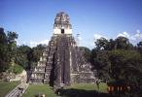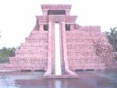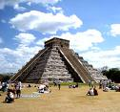

b) AGRICULTURE: The Mayas grew enough food to support large city populations. Farmers made this possible by clearing out the dense rain forests and then building raised fields.

c) LEARNING and SCIENCE: Perhaps the most impressive achievements of the Mayas was their advanced learning. Mayas developed a hieroglyphic (picture writing) system of writing and recorded much of their knowledge in books made of tree bark.
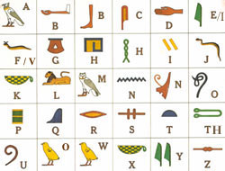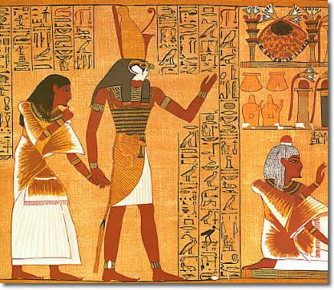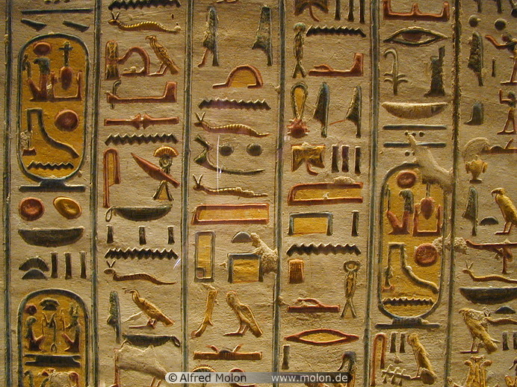
Mayan priests developed a very accurate 365-day calendar. The Mayan calendar was very advanced, and consisted of a solar year of 365 days. It was divided into 18 months of 20 days each, followed by a five-day period that was highly unlucky. They also used a numbering system and understood the concept of zero before Europeans did.
Parts of the Mayan culture are still alive today. In addition to their pyramids and temples - many of which are still standing - millions of people in Guatemala and southern Mexico still speak Mayan languages today.

