#213
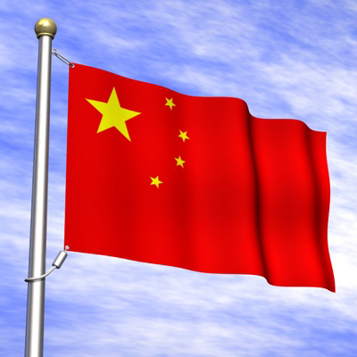
CHINA

Does anyone remember the last time we talked about China in class? Today, China is the most populous nation in the world. There’s one small thing I forgot to mention before this – in today’s world, there are actually two Chinas! The China that we talk about all the time is officially known as the “People’s Republic of China.” It is a communist state on the Asian mainland. It has a vast land area and many natural resources. Taiwan, (a.k.a. “Republic of China”), is a small island that today is one of the most economically successful Asian countries. It has a non-communist government. The People’s Republic still considers Taiwan a part of China. Confused yet?
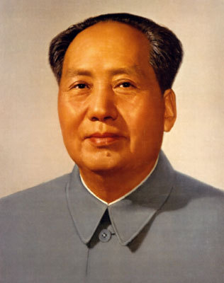
COMMUNIST RISE TO POWER

Before World War II, there was a Chinese Civil war going on between the communists (led by Mao Zedong) and the Chinese government (led by Chiang Kai-Shek). What is a “civil” war? As we know, during the late 1930s-1940s, Japan attacked and took over large parts of China. During this time, Mao (communists) united with the government (nationalists) to fight the Japanese. Where else have we seen people who did not like one another unite because they have a common enemy?
After WWII was over and the Japanese were defeated, the civil war began again over control of China. In 1949, Mao’s communists were victorious. Mao won for several reasons. He won the support of huge amounts of the poorer Chinese by promising to give land to the peasants (connection – where have we heard of this before?) He also made good use of hit-and-run guerilla warfare. Chiang Kai-Shek (the loser), fled to the island of Taiwan with his followers. This is the beginning of the “two Chinas” – Mao’s Communist China and Chiang’s Nationalist China on Taiwan.
Mao set up the People’s Republic of China as a communist state in 1949. They wanted to transform China from an agricultural society into a modern industrial nation. What other country that we’ve studied looked to convert quickly to an industrial nation? What was this called? Under communism, literacy increased, old landlord and business classes were eliminated, and rural Chinese were provided with health care. However, Mao set up a one-party dictatorship that denied people basic rights and freedoms.

The Great Leap Forward
In 1958, Mao launched a program called the “Great Leap Forward.” He called on the people to increase agricultural and industrial output. To make farms more productive, he created communes, groups of people who live and work together and own the property together. Communes had production quotas, which were set amounts of agricultural or industrial output that they were supposed to produce. Where have we seen this type of arrangement before?
The Great Leap Forward failed. Commune-based industries turned out poorly made goods. At the same time, agricultural production declined. Bad weather also added to the downturn, creating widespread famine.

The Cultural Revolution
In 1966, following the failure of his Great Leap Forward, Mao launched the “Cultural Revolution” to renew people’s loyalty to communism. It was designed to further cement communism in the country by removing capitalist elements from Chinese society. Mao told the people that landowners, factory owners, and better-off peasants were considered of the “Capitalist Class” which exploited workers. He also feared that revolutionary peasants and workers were being replaced by intellectuals in running the country. Therefore, he shut down schools and universities throughout China and urged students to experience the revolution for themselves. Students formed groups of fighters called the Red Guards. They attacked professors and those of this “Capitalist Class”, many of whom were exiled or executed.
“Re-education” became a big part of Mao’s Cultural Revolution. Communist beliefs became required learning in all newly-opened universities and schools. Newspapers and books were controlled by the government and had to promote communism. Even art and music came under the direct supervision of the government. In other words, the government was now involved in every single aspect of a Chinese person’s daily life.

Tiananmen Square
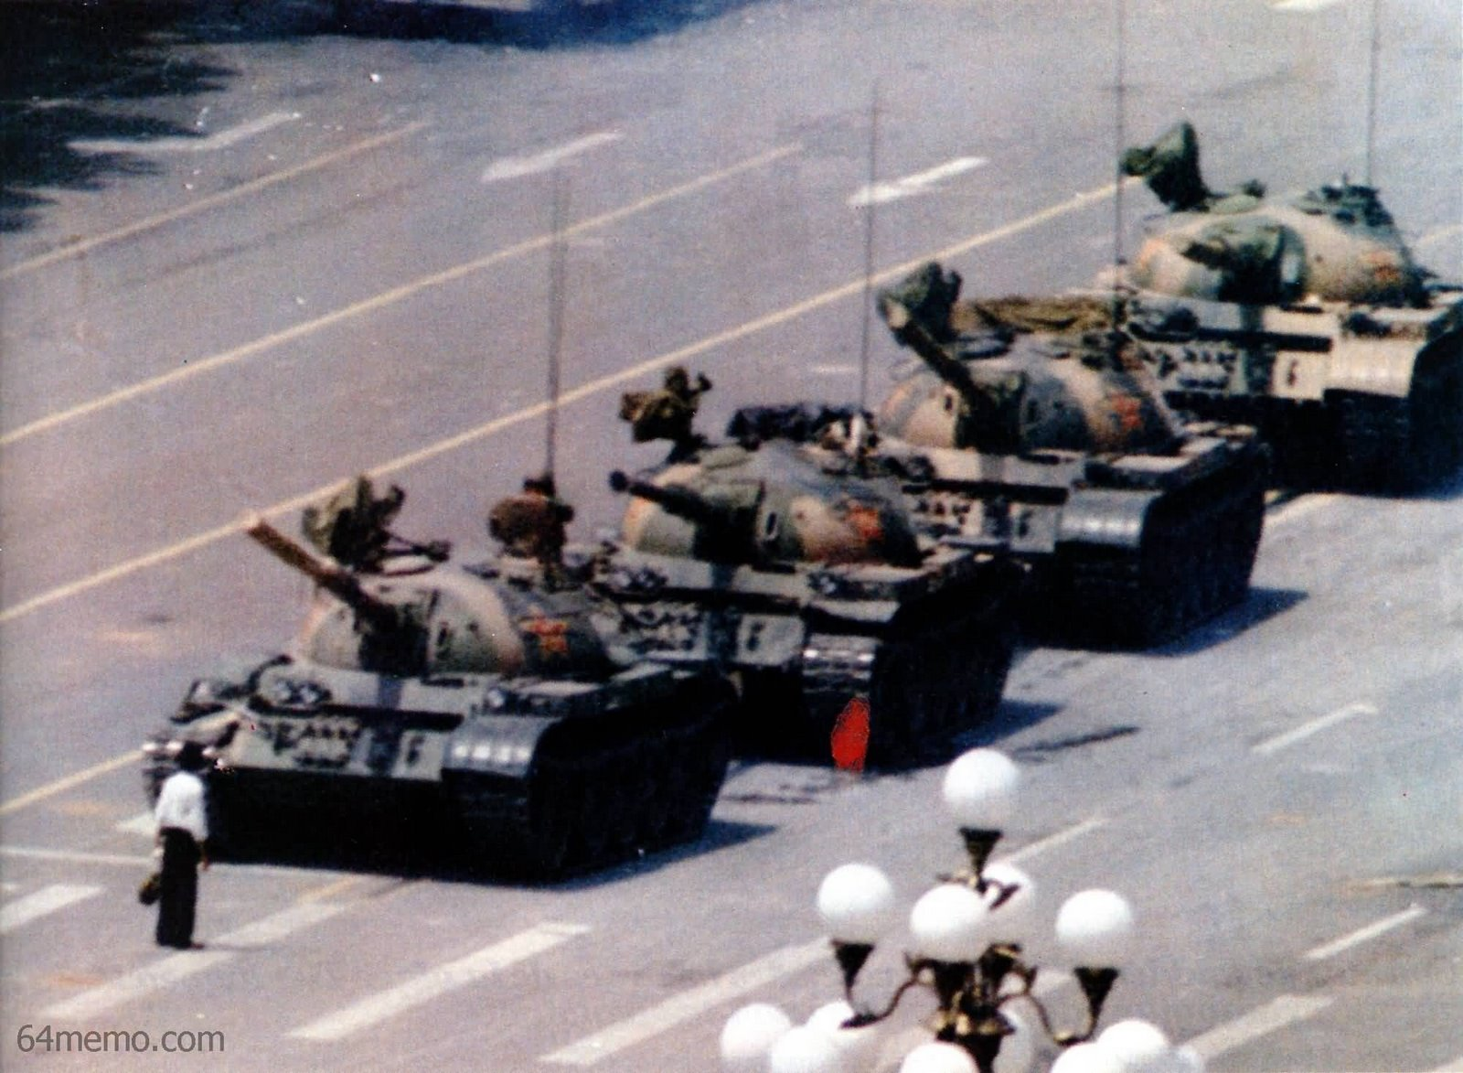
In the 1980s, average Chinese became tired of communist policies and demanded more freedoms and reforms. The government was willing to grant some economic reforms but not political ones. In May 1989, demonstrators in Beijing occupied Tiananmen Square, demanding more rights and freedoms. When the demonstrators refused to leave, the government sent in troops and tanks and crushed the protesters. Thousands of Chinese were killed or wounded. The incident showed how important it was to the Chinese communist leaders to maintain control. Order was more important than political freedom.
