#227
Aim: ______________________________________________________________________________

____________________________________________________________________________________

DO NOW:
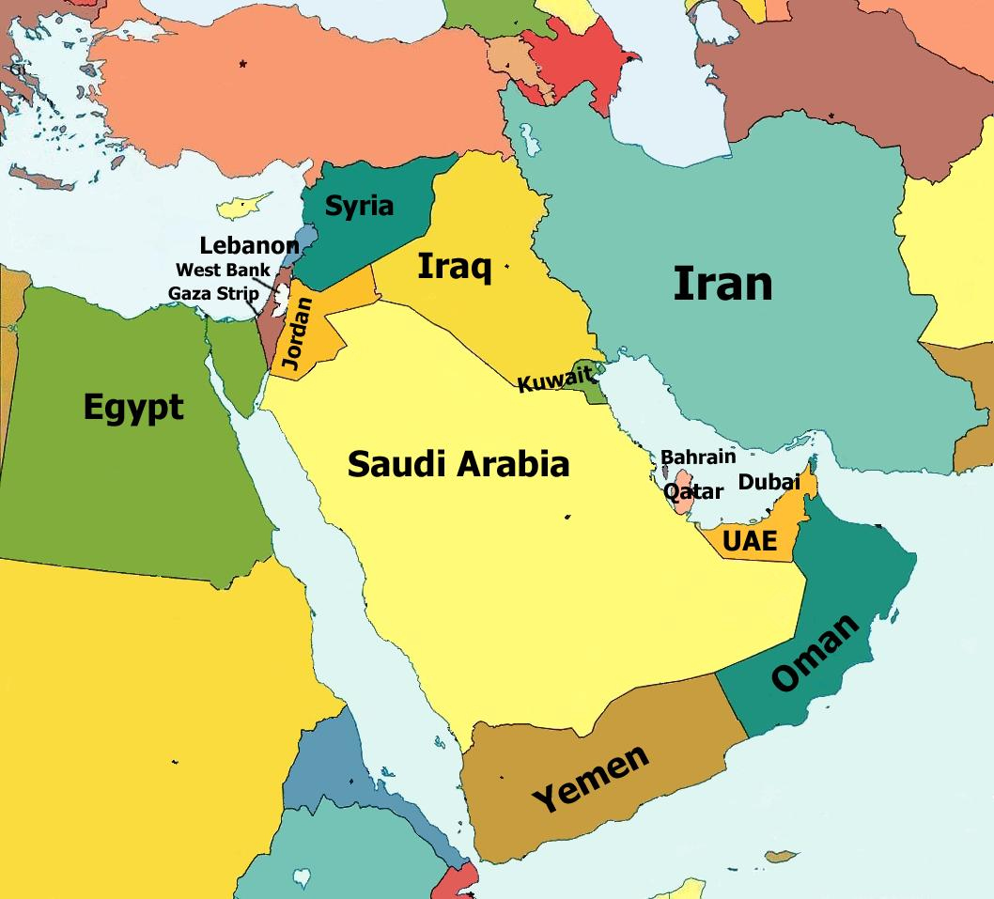
1. Look at the map on the left. What is the name of this area of the world?
______________ ______________

2. Which countries on this map did you not know existed? _____________________
________________________________________________________________________________________________________________________________________________________________________________________________

RESISTANCE TO IMPERIALISM
Directions: The following are the different resistance movements that we have already studied. Fill in the blanks.

1. In 1857, the people of India revolted in order to end foreign domination in an event known as the ________ _________. They lost in their quest to end foreign domination. As a result, India became an English colony for the next 90 years.

2. In 1900, the ________ ___________ was an event in China where students protested against foreign control but lost. China was continued to be split into “spheres of influence” by European countries.

3. Prompted by fear would be colonized by western nations, Japan began to emphasized westernization so that they could compete with Europe and not be colonized. This movement was called the __________ ____________.

