#52
Aim: ___________________________________________________________________

________________________________________________________________________

DO NOW

1) If you could be reborn as someone (person) or something (animal) else, what would you come back as? Why?

2) CHALLENGE: What is the belief that our souls are reborn as different people of animals called?

1) What do you see in the pictures above?
2) What inferences can you make about Hinduism based on these pictures?
3) Write down anything you know about Hinduism. In what country/civilization do you think Hinduism developed? Take a guess.
Name: ___________________________ Class: 10-_____
Religion:  Hinduism | Who, When, Where | Key Terms and Definitions | Major Beliefs
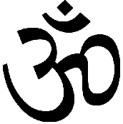  Polytheistic/ Monotheistic  (Circle One)  Name of Deity (god(s)) (if any): | Sacred Text(s):  Founder:

