#90
Greece: Alexander the Great and the Hellenistic Age

Last class we learned about the two most powerful Greek city-states, Sparta and Athens. We learned that Sparta was a strict, rigid warrior society. We learned that Athens valued education, culture, music, and art and that it became the center of Greek culture, and the site of the first democracy in the world. Since these two Greek city-states were so different, conflict between them was inevitable (meaning unavoidable). Athens became very powerful and Sparta resented it. Sparta favored their government, an oligarchy (ruled by a few) to the Athenian democracy (ruled by the people). Athens was becoming too powerful so Sparta went to war with Athens. This war, called the “Peloponnesian War”, lasted 25 years. In the end, Athens lost for a number of reasons. First of all, Athenians knew that they weren’t as militarily strong as Sparta so they retreated behind the walls of their city to wait it out. However, this backfired on them. With so many people behind the walls of Athens, a plague (a disease) broke out that killed a third (1/3) of their population. Athens was greatly weakened by this plague. Also, Sparta began to get aid (or help) from outsiders. This war ended Athens’ greatness and democracy began to fade away. However, even though Sparta won, both Sparta and Athens were so weakened by the war that they were both set up to be easily conquered. Today we will learn about how both Athens and Sparta were conquered by Philip of Macedonia and his son, Alexander.

Alexander the Great and the Hellenistic Age

Macedonia was a mountain kingdom north of Greece. In the 300s B.C., Philip of Macedonia conquered Greece, which had been weakened by 25 years of civil war between Athens and Sparta. His son, Alexander (later known as “the Great”) was with Philip of Macedonia during his conquest of Greece. Instead of destroying all things Greek, Philip of Macedonia and Alexander the Great embraced Greek culture. When Philip of Macedonia died, Alexander took over the throne at 20 years old. Alexander the Great went on to conquer most of the known world including Egypt, Persia, and parts of India. When Alexander the Great conquered Egypt at the age of 25, the Egyptians welcomed him. The Egyptians crowned Alexander as their Pharaoh and declared him to be a god. Alexander the Great marched with his army for 11 years and over 20,000 miles, and never lost a battle. He united an area of over 22 million square miles under Greek rule. He made Greek the official language for government, learning and commerce.
This was the beginning of the Hellenistic Age. The word "Hellenistic" comes from the Greek word meaning "to imitate, or copy, the Greeks." This new Hellenistic culture blended aspects of Greek, Persian, Egyptian, and Indian life. This new culture gave more rights and opportunities to women, who even gained some political power. However, when Alexander the Great was 32 (only 12 years after becoming King) he caught a cold, which turned into a fever, and he died. His death created a “power vacuum” and Alexander the Great's empire fell apart. However, even though Alexander’s empire fell apart soon after his death, Hellenistic culture had a lasting impact on the regions he had ruled. His death and the downfall of his empire set the state for the Romans to take over, which we will be learning about in the coming days.

Greek and Hellenistic Contributions

Ancient Greek and Hellenistic culture left a lasting legacy. In addition to their ideas about government, Greeks made contributions in philosophy, literature, science, and the arts.

I. Philosophy: Greek thinkers tried to use observation and reason to understand the way things happened. The Greek called these thinkers “philosophers,” a word that means "lovers of wisdom." Three of the most famous Greek philosophers were Socrates, Plato, and Aristotle. We will learn more about these three philosophers in the next lesson.

II. Literature: The first Greek plays developed from religious festivals. Stories of gods usually served as the basis for plays. Aeschylus, Sophocles, and Euripides write tragedies (plays that told stories of human conflict.) Can you name any tragedies that you have read during your time at Mott Haven? Other Greek playwrights wrote comedies. In addition, the Greek Poet Homer wrote epic poems that inspired many later writers. Greeks applied observation and logic to their writing of history. The Greek historian Herodotus is often called the Father of History because of his careful historical writings.

III. Arts and Architecture: The Greeks believed in beauty, balance, and order in the universe. Greek art and architecture (the design of buildings and structures) reflected those ideas. Greek paintings and statues were lifelike, but they also showed the human body in its most perfect form. The most famous Greek building is the Parthenon.
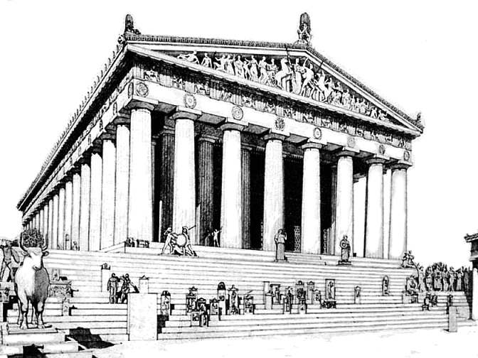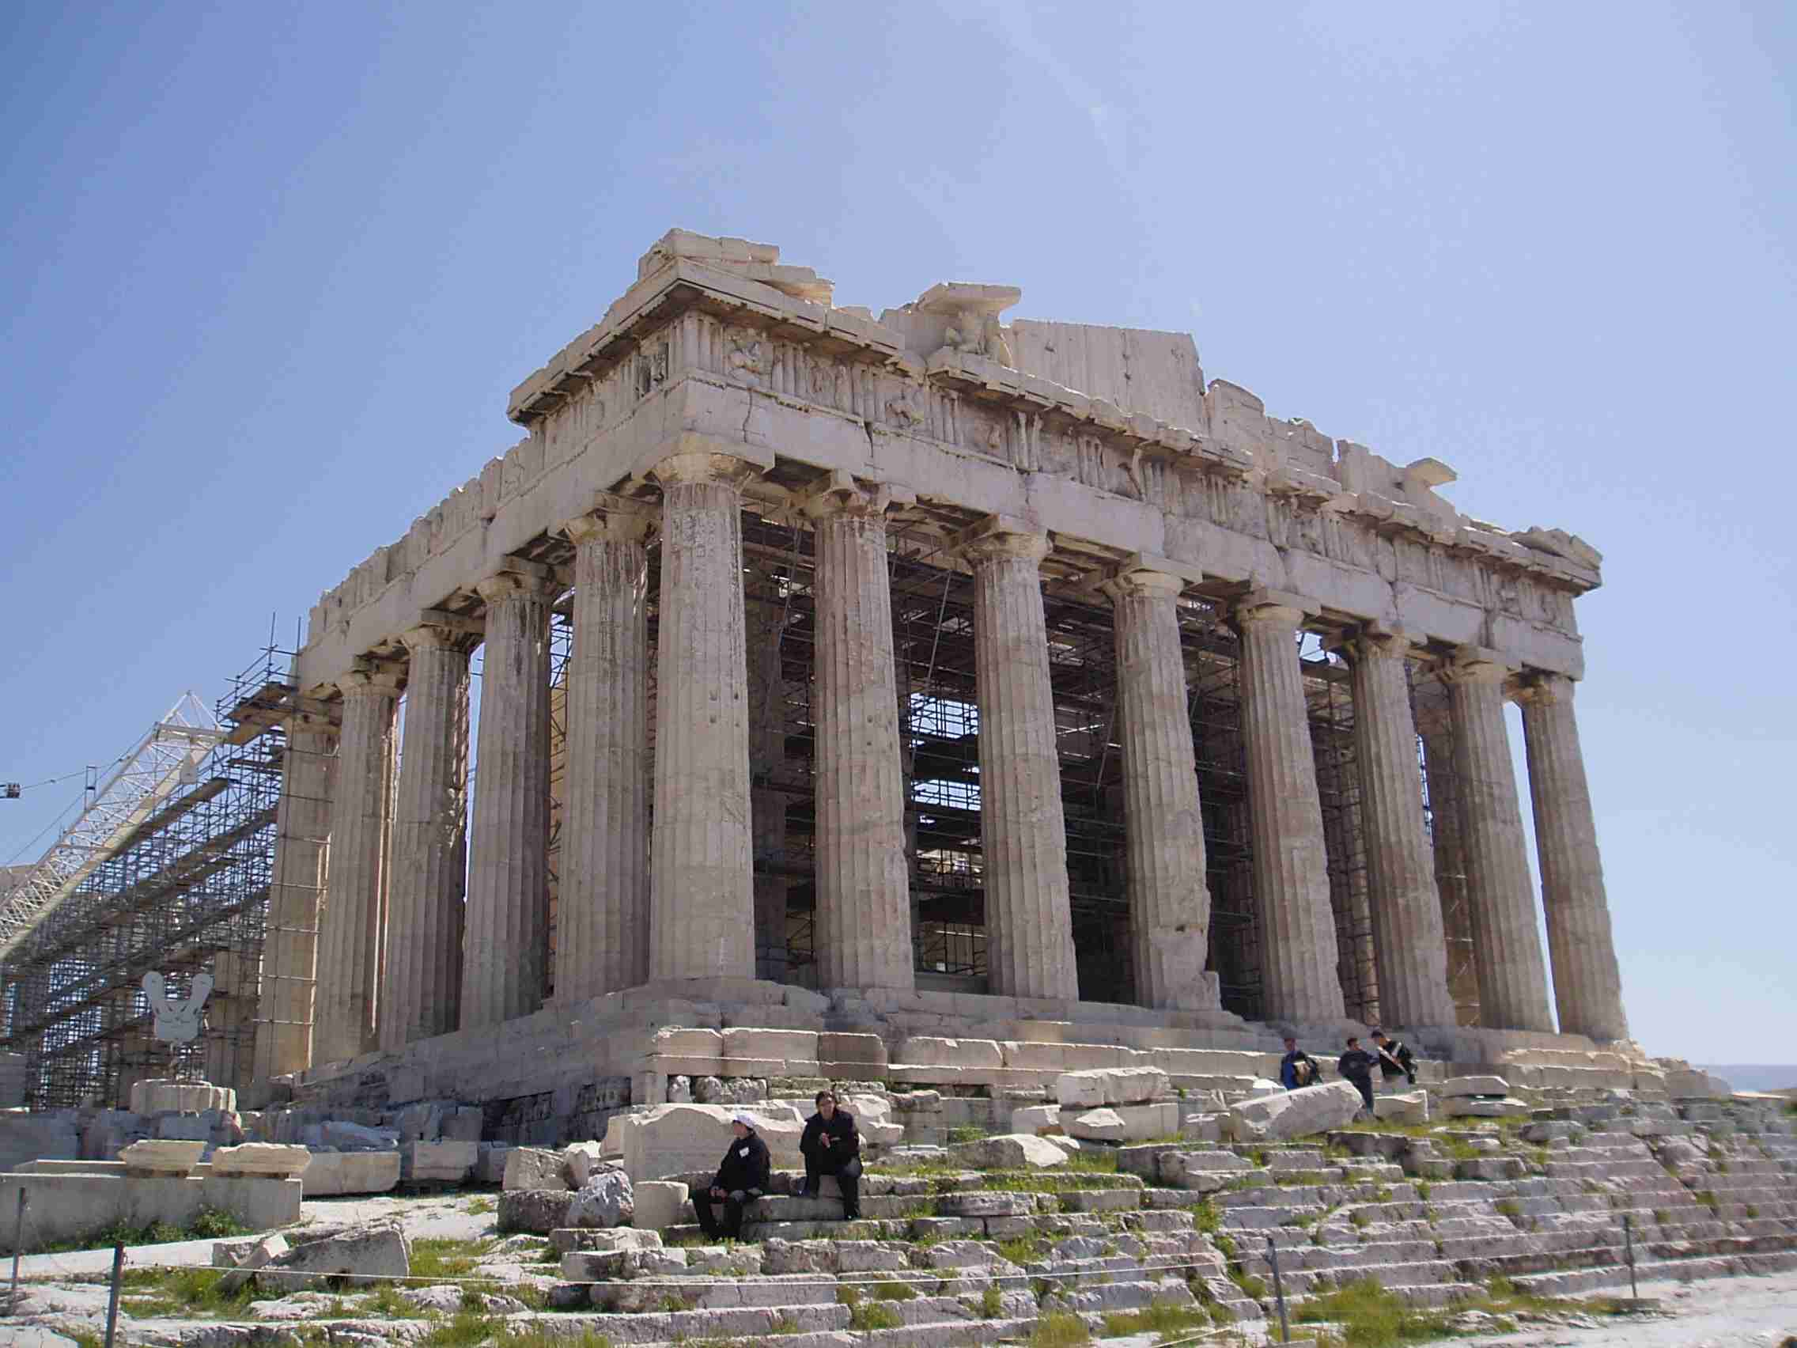

Architects today still use ancient Greek ideas, such as Greek column styles, in their buildings.

IV: Science: The Greek astronomer (someone who studies the stars and planets) named Aristarchus discovered that the earth rotates on its axis and moves around the sun. Archimedes explored the principles of the lever and pulley. Hippocrates, a Greek physician (doctor) studied the causes of illness and looked for cures.

V: Mathematics: Greek and Hellenistic thinkers made great strides in mathematics. Pythagoras (sound familiar?) developed a formula to measure the sides of a right triangle. Do you remember the Pythagorean theorem? What is the formula? Another Greek mathematician, Euclid, wrote a book that became the basis for modern geometry. How boring would math class be without these great Greek innovative thinkers!!!
VI. Other: Some of the gifts the ancient Greeks gave to the world include:
- Trial by Jury
- Greek Myths
- Democracy
- The Olympics
Which of these ancient Greek contributions do you think affects your current life the most? Why?

Which one of these ancient Greek contributions do you think is the coolest? Why?

