#98
Rome
We are smack in the middle of our 4th unit entitled "Classic Civilizations." The two classic civilizations we will cover during this unit are Ancient Greece and Ancient Rome. These two civilizations have many things in common but also have very large differences. Last class, we finished learning about Greece. Today we will begin our study of Rome, which is located in Italy.
The traditional date given for the founding of Rome is 509 B.C., when the Romans drove out the Etruscans who had ruled them. The Etruscans are mysterious peoples who settled in Italy somewhere between 900 and 800 B.C. We don't know where the Etruscans came from, but historians think that they came from somewhere to the east of the Mediterranean Sea. We will never really know where they came from or why they settled in Italy. We do know that when they came to Italy, they brought civilization with them. At that time, Rome was only a small village. The Romans were only villagers during the rise of the Etruscan civilization. However, while the Etruscans were busy building their power over Italy, the Roman village grew and eventually around 509 B.C. they drove the Etruscans out.

I. Geography:
Rome is located in the center of Italy. Italy is a small peninsula located in the Mediterranean Sea and is shaped like a boot. Unlike the geography of Greece, Italy’s geography helped its people to unite. There were few natural barriers, unlike the huge mountains that separated the Greek city-states. Also, the land was fertile and flat, so it was great for growing crops. Since food was easy to grow, the fertile land helped to support a large number of people so the population could grow. In addition, the location of the Italian peninsula helped Romans to move easily through the lands of the Mediterranean. Rome was a crossroads – from Rome it was easy access to northern Africa, Palestine, Greece and the Iberian Peninsula. Have you ever heard the saying "All roads lead to Rome"? What do you think this saying means? Draw in Italy and Greece in the 2nd map below:
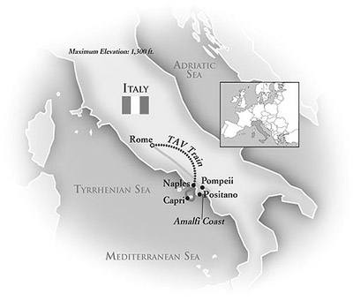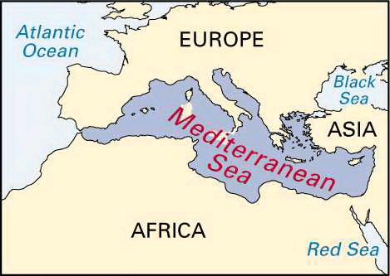
The geography of Rome also helped to make Rome a safe place. It was protected by the Alps (a set of mountains) to the North and water in every other direction. Since natural barriers protected Rome, it could develop a civilization safely. And, since Romans could easily travel to so many other places, they could trade with other civilizations, spread their influence, and possibly take over neighboring lands.

II. The Government:
The government in early Rome was a monarchy. A monarchy is a system of government that is ruled by one supreme ruler, like a King or dictator. Can you think of modern examples of monarchies?
However, after the first 7 Roman Kings, or monarchs, the Romans decided they did not want to have kings anymore. They decided that they wanted to have the power to choose their leaders to have a say in the decisions that were being made. What type of government does this sound like?
So, fed up with their monarchy, the Romans created a new form of government called a Republic. In a Republic, government officials were chosen by the people. The word 'Republic' itself comes from the Latin (the language of the Romans) words 'res publica' that mean 'public matters' or 'matters of state'. Romans were very proud of their system of government. They thought their Republic was much better than a monarchy and they feared and hated anything that resembled a monarchy.
The most powerful people in the Republic were a group called the Senate. The Senate was made up of 373 appointed citizens that made most of the decisions about Rome. The Senate also appointed a small group to rule over the rest of the Senate, but only for a year at a time.
However, this was not an equal society. The Senate was almost entirely made up the highest class of Romans (called Patricians). Even though the Patricians were a very small proportion of society as a whole, they held 368 out of 373 seats. This means that the commoners (called Plebeians) who were the vast majority of the population had only 5 seats on the Senate – i.e., their vote meant very little.
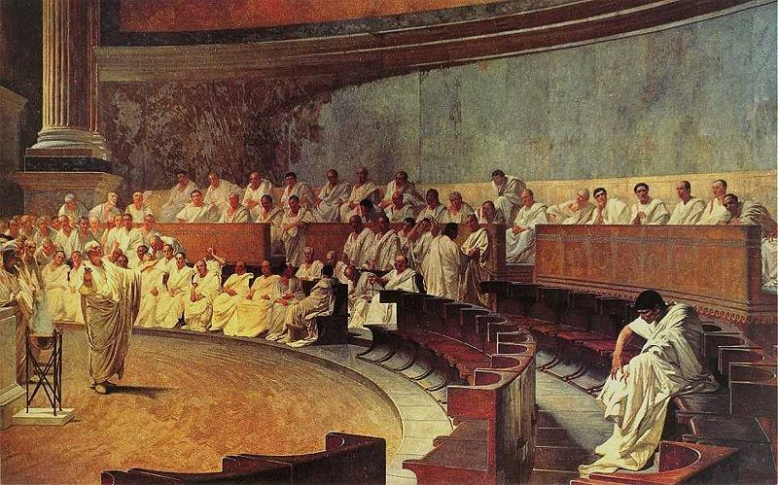
The Roman Republic was a very successful government. It lasted from 510 B.C. until 23 B.C., which is almost 500 years. That might not sound like much, but compare it to the United States of America which has only existed since 1776 – less than 250 years.

III. The Social Structure:
Just like all the other Ancient Civilizations you have studied about in history class, Roman society was organized into a social hierarchy. Rome was divided into 4 main social classes. The highest class was the nobles of Rome. They were called 'patricians'. They had all the real power in Rome. Most of the seats in the Senate were reserved for patricians. The second highest class was the equestrians (sometimes they are called the 'knights'). Their name means the 'riders', as they were given a horse to ride if they were called to fight for Rome. To be an equestrian you had to be rich. The next class was the plebeians. They were free people but they were commoners. They had practically no say at all in what happened in Rome. The lowest class was the slaves. They were owned by other people and had no rights at all.

Dictator (only when needed and only for one year)

Senators

Patricians

Equestrians

Plebeians

Slaves

